


STRATEGIC ANALYSIS OF
EVERA
A Field-Based Study of an Early-Stage Sustainable Beverage Startup

End Term Project – Strategic Management
NAME | ROLL NO.
Kaustabh Datta | P2511037
Raunak Singh | P2511056
Niveditha R Nair | P2511047
Suganthan Nakkeeran | P2511072
Aditya Agarwal | P2511007
Viren Badgujar | P2511076

Startup Name | EVERA
Sector | Beverages
Founders | Raunak Singh
Interviewee | Raunak Singh
Interviewer | Suganthan Nakkeeran
Interview Format | Remote

Table of Contents
Table of Contents 2
1. Introduction 5
Frameworks Applied 5
2. Startup Background and Opportunity Identification 6
Pain Points Observed 6
Core Idea Pillars 6
3. Market Opportunity and Industry Trends 7
Rising Caffeine Dependency 7
Growing Health Concerns 7
Sustainability Awareness 7
4. Product Innovation and Value Proposition 8
Formulation 8
Product Comparison 8
5. Production and Value Chain 9
Step-by-Step Process 9
Sourcing 9
Drying 9
Roasting 9
Grinding 9
Packaging 9
6. Kraft Paper Packaging — Sustainability Rationale & Cost 10
Why Kraft Paper? 10
Sustainability Alignment 10
Packaging Cost Structure 10
7. Cost Model Strategy 12
8. Revenue Model — B2C & B2B 13
B2C Revenue Streams 13
Retail / Direct-to-Consumer (DTC) 13
Subscription Model 13
E-Commerce Listings 13
Bundle and Gift Sets 13
B2B Revenue Streams 14
Café and HoReCa Supply 14
B2B Ingredient Supply 14
White-Label / Licensing 14
Corporate Wellness Programs 14
Consolidated Revenue Stream Overview 14
9. Distribution and Sourcing Channels 16
Sourcing Channels 16
Date Seeds 16
Chicory Roots 16
Kraft Paper Packaging 16
Distribution Channels 17
Phase 1: E-Commerce (Launch Stage) 17
Phase 2: Specialty Retail 17
Phase 3: HoReCa and Institutional 17
10. Target Market and Positioning (STP Analysis) 18
Segmentation 18
Demographic 18
Psychographic 18
Target Market 18
Positioning 18
11. Industry Analysis – Porter's Five Forces 19
Competitive Rivalry — Moderate 19
Threat of New Entrants — Moderate 19
Buyer Power — High 19
Supplier Power — Low to Moderate 19
Threat of Substitutes — High 19
12. Resource-Based View (RBV) 21
Sustainable Raw Material Source 21
Innovative Product Concept 21
Founder's Analytical Skills 21
Academic Network 21
13. VRIO Analysis 22
14. Porter's Generic Strategy 23
15. Strategic Challenges 24
Limited Financial Resources 24
Production Infrastructure 24
Product Development Complexity 24
Market Education 24
16. Strategic Recommendations 25
1. Focus on Product Validation 25
2. Build a Strong Brand Story 25
3. Strategic Partnerships 25
4. Direct-to-Consumer Marketing 25
5. Expand Product Variants 25
17. Conclusion 26

1. Introduction
The global beverage industry is undergoing a major transformation as consumers increasingly prioritize health, sustainability, and functional nutrition. Traditional caffeinated beverages such as coffee and energy drinks are widely consumed for productivity and alertness; however, excessive caffeine consumption is associated with issues such as acidity, sleep disturbances, anxiety, and metabolic stress.
This report presents a field-based strategic analysis of EVERA, a startup focused on developing a caffeine-free coffee alternative made from upcycled date seeds and chicory roots. Primary insights were gathered through an interview with the founder, along with supporting data from the startup's business presentation and market research.
EVERA aims to create a health-focused, sustainable beverage solution by transforming discarded date seeds into a functional coffee substitute. The venture integrates wellness trends, sustainability practices, and beverage innovation to address growing consumer demand.

Frameworks Applied
- Porter's Five Forces
- Resource-Based View (RBV)
- VRIO Framework
- Porter's Generic Strategy

2. Startup Background and Opportunity Identification
The idea for EVERA emerged from the founder's personal observations during his MBA program. He noticed that students and professionals increasingly rely on coffee to maintain productivity, often consuming multiple cups per day, while also experiencing negative side effects.

Pain Points Observed
- Acidity
- Sleep disturbances
- Anxiety
- Digestive issues

During research into sustainable food systems, the founder discovered that date seeds are commonly discarded as waste in food processing operations, despite having roasting properties capable of producing a coffee-like aroma. This insight led to the development of EVERA.

Core Idea Pillars
- Creating a healthy caffeine-free coffee alternative
- Upcycling food waste into a valuable beverage product

3. Market Opportunity and Industry Trends
The beverage market is evolving rapidly as consumers shift toward functional and wellness-oriented products. India's coffee powder market is expected to reach approximately $1.91 billion with a CAGR of 7.8% by 2030.

Rising Caffeine Dependency
- 74% of surveyed respondents consume coffee daily
- 62% want to reduce caffeine intake
- 82% believe there are no good caffeine-free alternatives available

Growing Health Concerns
- 89.8 million diabetics in India
- 235 million pre-diabetics
- Projected 156.7 million diabetes cases by 2050

Sustainability Awareness
Consumers are becoming more environmentally conscious and prefer products that reduce food waste, use sustainable ingredients, and promote responsible consumption. EVERA's use of upcycled date seeds directly addresses this concern.

4. Product Innovation and Value Proposition
EVERA differentiates itself by offering a caffeine-free coffee alternative made from roasted date seeds and chicory roots.

Formulation
- 60% Date Seed Powder
- 40% Chicory Root Powder

Product Comparison
Feature | Traditional Coffee | EVERA Blend
Caffeine | ~95 mg per cup | 0 mg
Acidity | High | Low
Sustainability | High water footprint | Upcycled waste
Health Benefits | Alertness | Digestive + Prebiotics

The product also aligns with multiple wellness perspectives including Ayurveda, homeopathy, and clinical health by promoting gentle energy, digestive health, and improved sleep quality.

5. Production and Value Chain
EVERA's value chain integrates sustainable sourcing and processing across five key stages:
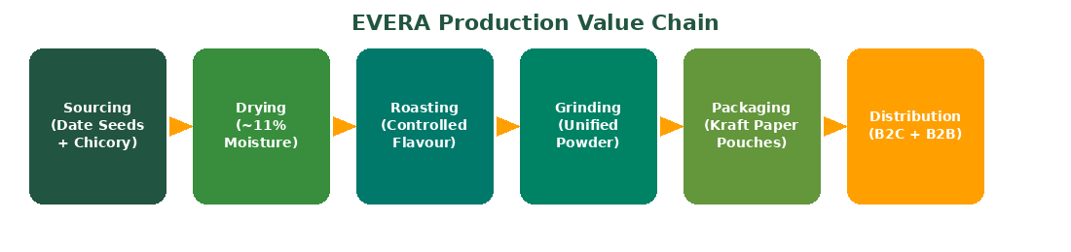

Step-by-Step Process

Sourcing
- Chicory roots sourced directly from farmers
- Date seeds collected from food processing factories as upcycled waste

Drying
- Moisture content reduced to approximately 11% for consistency

Roasting
- Controlled roasting to develop the characteristic coffee-like flavour and aroma

Grinding
- Both ingredients combined into a unified, uniform powder blend

Packaging
Finished product is packaged in kraft paper stand-up pouches — a deliberate choice rooted in sustainability. See Section 6 for a detailed rationale and cost breakdown.

6. Kraft Paper Packaging — Sustainability Rationale & Cost
Packaging is not just a protective vessel for EVERA — it is a brand statement. The decision to use kraft paper stand-up pouches is a strategic one, rooted in the company's core sustainability mission of transforming waste into value.

Why Kraft Paper?
Kraft paper is derived from unbleached wood pulp through the sulphate process, retaining the natural lignin of the wood fibre. Unlike conventional plastic packaging, kraft paper is:
- 100% biodegradable — breaks down naturally within weeks to months
- Recyclable and compostable — compatible with India's emerging waste management systems
- Chemical-free — no bleaching agents or synthetic coatings that leach into food
- Food-safe — compliant with FSSAI guidelines for dry powdered food products
- Durable — high tensile strength relative to weight, suitable for dry beverage products

Sustainability Alignment
EVERA's founding philosophy is built on upcycling — converting what is discarded (date seeds) into something of value. Kraft paper packaging extends this logic to the product's packaging layer:
The packaging echoes the product: just as date seeds are rescued from waste streams,
kraft paper avoids the plastic waste stream — completing EVERA's circular economy narrative.

This consistency in values strengthens brand credibility with eco-conscious consumers.

- Aligns with UN SDG 12 (Responsible Consumption) and SDG 13 (Climate Action)
- Preferred format for D2C wellness and organic brands — signals premium positioning
- Reduces carbon footprint vs equivalent PET or multilayer plastic pouches by an estimated 40–60%
- Supports EVERA's narrative in sustainability-focused retail (BigBasket Organic, health stores)

Packaging Cost Structure
While kraft paper commands a slight premium over basic plastic pouches, costs remain manageable at early scale and improve substantially with volume:
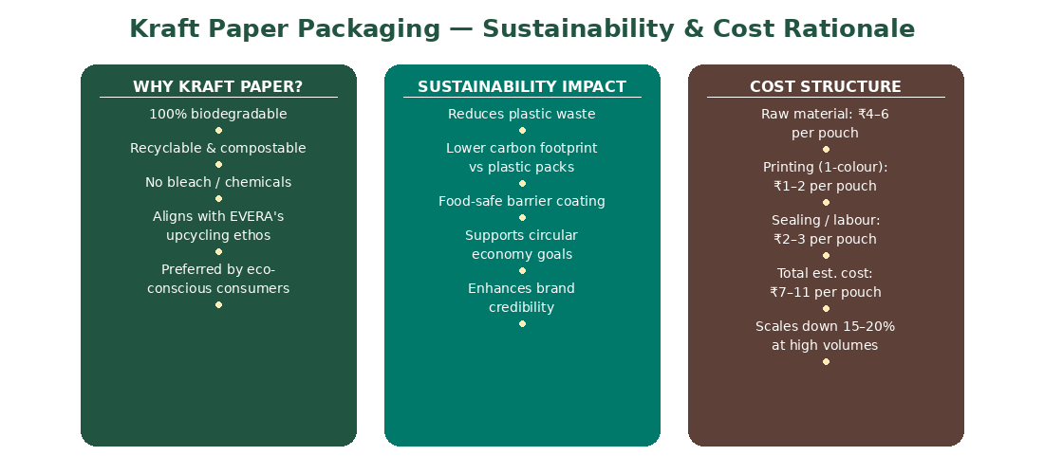
Cost Component | Est. Cost | Notes
Raw Material (kraft paper roll) | ₹4 – ₹6 | Per pouch — varies by gsm & vendor
Printing (1-colour label) | ₹1 – ₹2 | Flexographic print run
Sealing & Zipper fitment | ₹1 – ₹2 | Heat seal + resealable zip-lock
Labour / Processing | ₹1 – ₹2 | Semi-automated at small scale
Total Estimated Cost | ₹7 – ₹12 | Scales down 15–20% at volume

Cost Note: At a 100g retail price of ₹149–₹199, kraft packaging at ₹7–₹12 per unit
represents approximately 4–8% of MRP — a commercially viable and brand-justified cost.
At 10,000+ units/month, bulk procurement can reduce pouch cost to ₹5–₹8 per unit.

7. Cost Model Strategy
EVERA's cost strategy leverages a waste-to-value sourcing model that transforms discarded date seeds and directly-sourced chicory roots into a premium product at minimal raw material cost. This circular economy approach—combined with sustainable kraft paper packaging and capital-light e-commerce distribution—creates structural cost advantages over conventional coffee production while reinforcing the brand's sustainability narrative. By prioritizing variable costs and batch-based scalability, EVERA achieves break-even at 4,270 units per month (57% capacity utilization) while maintaining the flexibility to scale margins as production volumes increase.
Cost Component | Amount (₹)
A. Direct Materials
Date Seeds (315 kg) | 1,575
Chicory Roots (210 kg) | 8,400
Subtotal | 9,975
B. Processing Costs
Washing, Drying, Roasting, Grinding | 6,750
Quality Testing | 2,000
Subtotal | 8,750
C. Packaging
Kraft Pouches, Printing, Sealing | 60,000
D. Overhead Costs
Rent, Utilities, Equipment, Labor | 68,000
E. Marketing & Distribution
Digital Marketing & E-commerce | 40,000
Shipping (5,000 units @ ₹30) | 150,000
Sampling & Brand Development | 18,000
Subtotal | 208,000
F. Administrative
Salaries, Professional Services, Office | 46,000
TOTAL MONTHLY COST | 4,00,725
Cost per Unit (100g pack) | ₹80.15
Cost per Kilogram | ₹801
Pricing & Profitability
Selling Price (per 100g) | ₹174
Gross Margin per Unit | ₹93.85
Gross Margin % | 54%
Monthly Revenue (5,000 units) | ₹8,70,000
Monthly Profit | ₹4,69,275
Break-even Volume | 4,270 units

8. Revenue Model — B2C & B2B
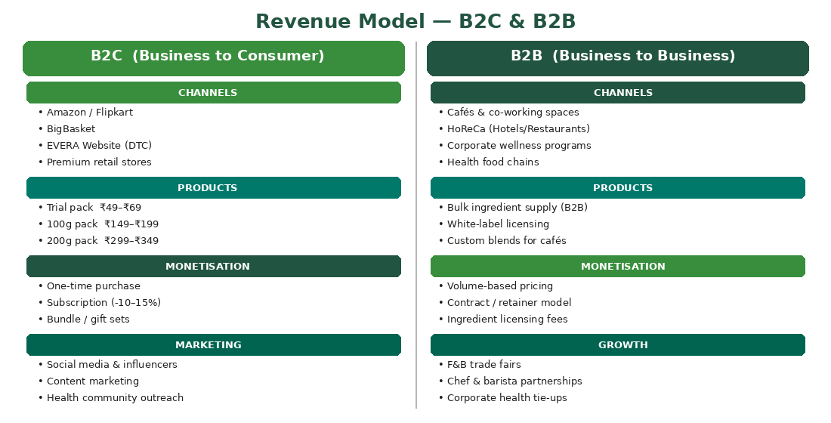

B2C Revenue Streams
The B2C model targets end consumers directly, maximising margin and brand ownership.

Retail / Direct-to-Consumer (DTC)
- Trial pack (₹49–₹69): Low-commitment entry point to reduce purchase hesitation
- 100g pack (₹149–₹199): Core SKU for regular individual users
- 200g pack (₹299–₹349): Family / power-user pack with better value

Subscription Model
- Auto-renewal monthly subscriptions at 10–15% discount
- Predictable recurring revenue — reduces customer acquisition cost over lifetime
- Builds habitual consumption and loyalty

E-Commerce Listings
- Amazon and Flipkart: Pan-India reach via established logistics
- BigBasket: Access to health-conscious, planned grocery shoppers
- EVERA's own website: Highest margin channel; enables storytelling and brand control

Bundle and Gift Sets
- Seasonal gifting (Diwali, New Year wellness kits)
- Value bundles: 3-pack, starter kit with brewing instructions

B2B Revenue Streams
The B2B model targets businesses that serve EVERA's end-consumer segments, providing volume-based revenue.

Café and HoReCa Supply
- Supplying cafés, co-working spaces, and boutique restaurants
- Custom serving packs and menu integration (latte-style, hot brew, cold brew)
- Revenue through bulk wholesale pricing with recurring orders

B2B Ingredient Supply
- Wholesale supply of date-seed powder and chicory powder to food manufacturers
- Long-term supply contracts ensure stable, predictable revenue
- Minimal marketing cost — relationship-driven sales model

White-Label / Licensing
- Private-label blends manufactured for wellness and health brands
- Licensing the EVERA formulation to regional beverage companies
- Asset-light model — royalty or per-unit licensing fees

Corporate Wellness Programs
- Partnering with corporate HR / wellness teams for office vending and subscription kits
- High ticket per account — recurring monthly delivery contracts
- Emerging channel with strong growth potential post-COVID wellness awareness

Consolidated Revenue Stream Overview
Revenue Stream | Description | Strategic Value | Type
Retail / DTC Sales | Trial ₹49–69 · 100g ₹149–199 · 200g ₹299–349 | High margin, brand-building | B2C
Subscription Model | 10–15% discount · Auto-renewal monthly | Predictable recurring revenue | B2C
E-Commerce Listings | Amazon, Flipkart, BigBasket | Scale & discoverability | B2C
Café / HoReCa Supply | Bulk pricing · Custom serving packs | Volume-led, lower margin | B2B
B2B Ingredient Supply | Wholesale date-seed / chicory powder | High volume, stable contracts | B2B
White-Label / Licensing | Private label blends for wellness brands | Asset-light, royalty income | B2B

9. Distribution and Sourcing Channels
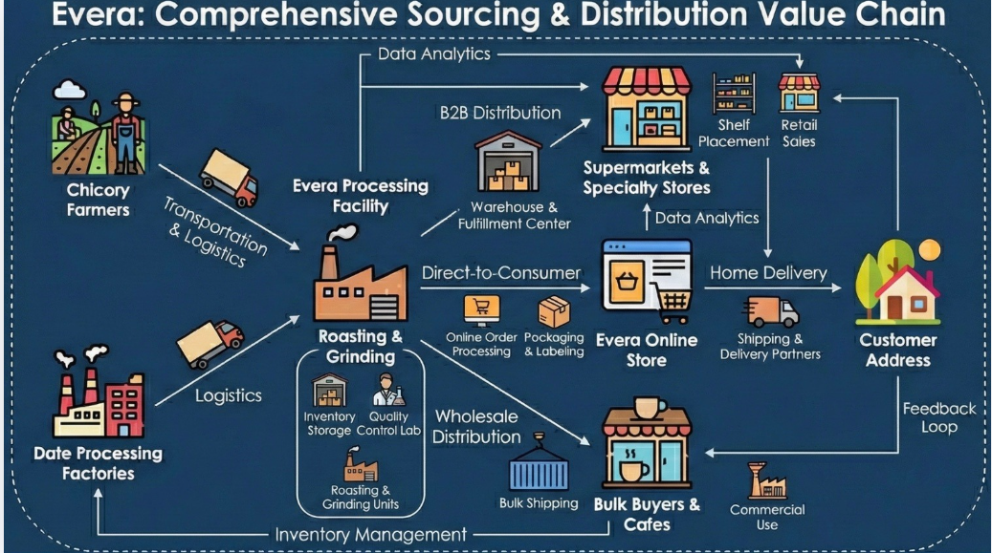

Sourcing Channels
EVERA's sourcing strategy is built on three pillars: cost-efficiency through upcycling, supply-chain reliability, and sustainability credentials.

Date Seeds
- Primary source: Date processing factories and mills in Rajasthan, Gujarat, and Maharashtra
- Seeds are a zero-value by-product for sellers — low or no raw material cost to EVERA
- Collection logistics: Direct tie-ups with 2–3 processing units for consistent supply
- Quality check: Moisture testing and visual grading before acceptance

Chicory Roots
- Sourced directly from chicory farmers in Andhra Pradesh and Karnataka — major growing belts
- Direct farm procurement eliminates middlemen and reduces cost
- Seasonal planning required: Chicory has defined harvest windows
- Backup: Chicory powder from established spice processors as contingency

Kraft Paper Packaging
- Locally sourced from kraft pouch manufacturers in Delhi NCR / Mumbai
- Minimum order quantity (MOQ) of ~500–1,000 units at early stage
- Custom printing added as volumes scale beyond 5,000 units/month

Distribution Channels
EVERA's distribution strategy follows a phased rollout — starting with digital channels for low capital deployment and expanding into physical retail as brand awareness builds.

Phase 1: E-Commerce (Launch Stage)
- Amazon, Flipkart, BigBasket — pan-India reach from Day 1
- EVERA website (Shopify / WooCommerce) — DTC for maximum margin and data ownership
- Quick Commerce (Blinkit, Zepto) — future addition for impulse and convenience purchases

Phase 2: Specialty Retail
- Health food stores: Organic World, Nature's Basket, local wellness outlets
- Modern trade: Premium supermarket chains in Tier 1 cities
- Pharmacies and nutraceutical chains — leveraging health positioning

Phase 3: HoReCa and Institutional
- Cafés and co-working spaces (WeWork, 91Springboard, independent cafés)
- Hotel chains and airline catering — aspirational long-term distribution
- Corporate offices via HR wellness program partnerships

Distribution Insight: EVERA's go-to-market prioritises e-commerce and DTC in the launch phase
to minimise working capital lock-in and gather direct consumer feedback.
Physical retail expansion follows brand validation — a capital-efficient sequencing strategy.

10. Target Market and Positioning (STP Analysis)
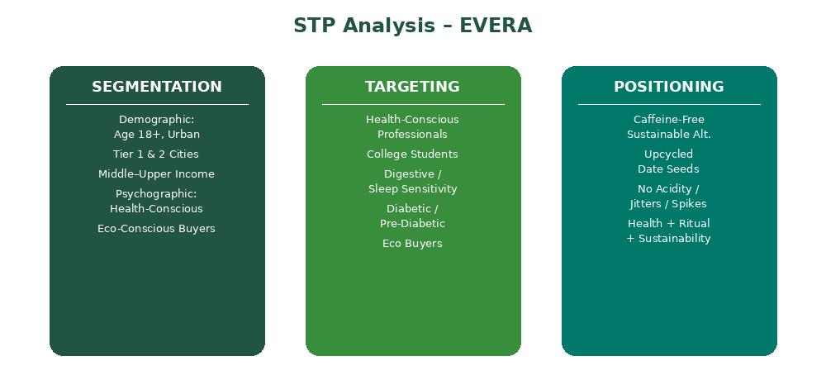

Segmentation

Demographic
- Age 18+
- Urban Tier 1 and Tier 2 cities
- Middle to upper income groups

Psychographic
- Health-conscious consumers
- Eco-conscious buyers
- Coffee drinkers seeking gentler alternatives

Target Market
- Health-conscious professionals
- Students who consume coffee regularly
- Individuals with digestive or sleep sensitivity
- Diabetic or pre-diabetic consumers
- Environmentally conscious buyers

Positioning
"A caffeine-free sustainable coffee alternative made from upcycled date seeds
that preserves the comforting ritual of coffee without acidity, jitters, or blood sugar spikes."

Emphasis: Health · Sustainability · Lifestyle Experience

11. Industry Analysis – Porter's Five Forces
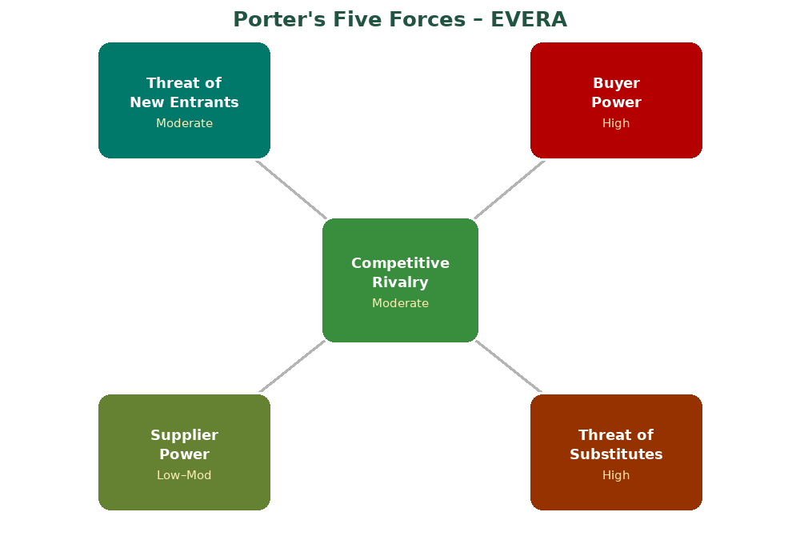

Competitive Rivalry — Moderate
The coffee market is highly competitive with global brands such as Nestlé and Starbucks. However, the caffeine-free coffee alternative segment remains relatively underdeveloped, creating room for differentiation.

Threat of New Entrants — Moderate
- Manufacturing requirements create entry barriers
- Branding and distribution challenges slow new entrants
- Niche wellness beverage startups are emerging rapidly

Buyer Power — High
Consumers have many beverage choices including coffee, tea, herbal drinks, and energy drinks. Strong differentiation is therefore necessary.

Supplier Power — Low to Moderate
Date seeds are a low-value byproduct, which may provide cost advantages. However, sourcing consistency and processing quality remain important.

Threat of Substitutes — High
- Decaffeinated coffee
- Herbal teas
- Functional beverages
- Plant-based drinks
EVERA must differentiate strongly through taste and demonstrable health benefits.

12. Resource-Based View (RBV)
EVERA's competitive advantage lies in several key internal resources:

Sustainable Raw Material Source
The use of discarded date seeds creates both cost advantage and sustainability value, forming the core of EVERA's differentiation.

Innovative Product Concept
The combination of chicory and date seeds creates a unique coffee alternative that is difficult for competitors to replicate easily.

Founder's Analytical Skills
The founder emphasized strong analytical and research capabilities that helped evaluate market trends and product feasibility.

Academic Network
- Faculty mentorship
- Research databases
- Peer feedback
These resources compensated for early financial constraints and helped validate the concept before commercialization.

13. VRIO Analysis
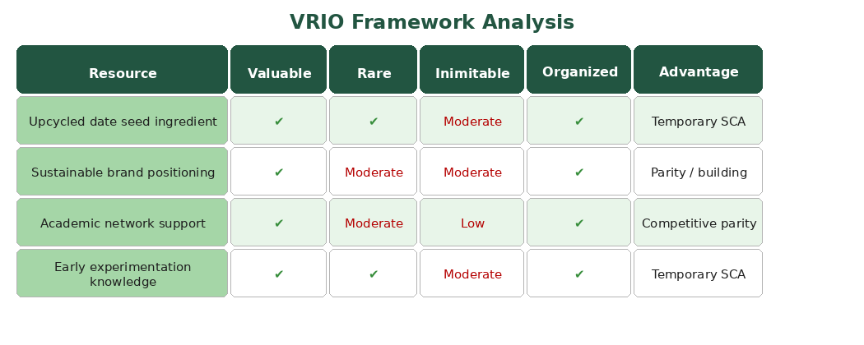
The VRIO analysis reveals that EVERA holds temporary sustainable competitive advantage (SCA) in its core resources — particularly the upcycled date seed ingredient and early experimentation knowledge. To convert these into lasting competitive advantages, EVERA must strengthen branding and distribution before competitors enter the niche.

14. Porter's Generic Strategy
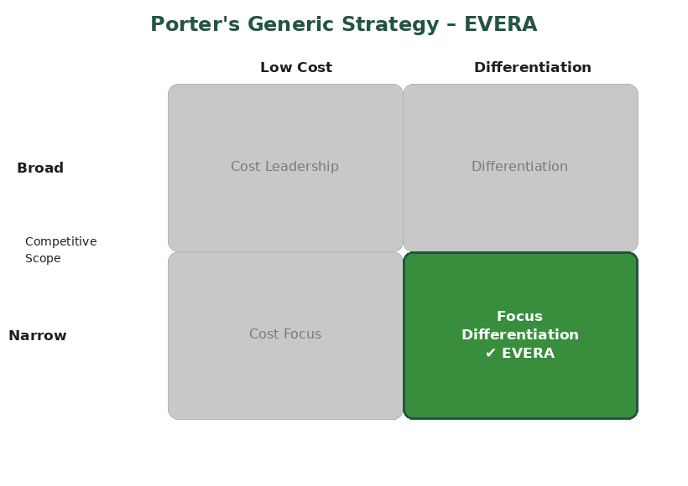
EVERA adopts a Focus Differentiation strategy — targeting a narrow, specific market segment (health-conscious, eco-aware urban consumers) with a highly differentiated product (upcycled, caffeine-free beverage). This is reflected in its premium yet accessible pricing, niche distribution channels, and strong sustainability narrative.

15. Strategic Challenges

Limited Financial Resources
As a student entrepreneur, the founder operates with limited capital, restricting large-scale production and marketing.

Production Infrastructure
Food processing requires specialized equipment such as dryers, roasters, and grinders — all of which can be costly for early-stage startups.

Product Development Complexity
Achieving consistent flavour profiles requires precise roasting parameters and continued experimentation.

Market Education
Consumers may initially be unfamiliar with date-seed coffee alternatives, requiring strong awareness campaigns and educational marketing.

16. Strategic Recommendations

1. Focus on Product Validation
Conduct pilot production batches and gather customer feedback to refine taste, texture, and formulation before scaling.

2. Build a Strong Brand Story
Highlight the product's sustainability narrative and wellness benefits to differentiate from traditional coffee.

3. Strategic Partnerships
- Cafés and specialty coffee shops
- Health food stores
- Wellness and fitness brands

4. Direct-to-Consumer Marketing
Leverage social media, influencer marketing, and content marketing to build early brand awareness among target segments.

5. Expand Product Variants
- Cold brew alternatives
- Flavoured blends
- Ready-to-drink beverages
- Café-based experiences

17. Conclusion
EVERA represents a promising example of innovation emerging from sustainability and wellness trends. By transforming discarded date seeds into a caffeine-free coffee alternative, the venture combines health benefits, environmental responsibility, and beverage innovation.
Although the startup is currently in the early stages and faces challenges related to resources, production, and market awareness, its concept aligns strongly with evolving consumer preferences.
If supported by strategic experimentation, partnerships, and effective branding, EVERA has the potential to establish itself within the rapidly growing functional beverage market.

Key Insight:
"Valuable business opportunities often emerge at the intersection of consumer health needs,
sustainability concerns, and creative resource utilization."

